**1. INTRODUCTION**

**1.1. Project Overview**

Heart Disease Analysis is a data visualization project designed to analyse and interpret heart disease data using interactive dashboards and storytelling techniques. The application leverages Tableau to transform raw healthcare data into meaningful visual insights that help identify key risk factors such as smoking, obesity, diabetes, physical inactivity, and age-related patterns. By integrating the dashboard with a Flask web application, the system allows users to access and explore heart disease insights through a browser interface in real time.

The project aims to support healthcare professionals, policymakers, and individuals in understanding the major factors contributing to cardiovascular diseases. Instead of manually analysing large datasets, users can rely on interactive visualizations to quickly identify trends, correlations, and high-risk groups. The application is built using Tableau Public for data visualization and Flask for web integration, ensuring accessibility, interactivity, and user-friendly design.

Overall, the Heart Disease Analysis project demonstrates the practical use of business intelligence and data visualization tools in healthcare analytics by providing a structured, interactive, and insightful solution for heart disease data exploration and decision-making.

**1.2. Objectives**

The main objectives of the Heart Disease Analysis using Tableau and Flask project are:

• To develop an interactive data visualization system to analyze heart disease data using Tableau

• To identify and analyze key risk factors such as smoking, obesity, diabetes, physical inactivity, and age groups contributing to heart disease

• To transform raw healthcare data into meaningful visual insights through dashboards and stories

• To integrate Tableau dashboards with a Flask web application for browser-based accessibility

•To provide a simple and user-friendly web interface for exploring heart disease insights

• To enhance understanding of cardiovascular risk patterns through interactive and real-time data visualization

**2. Ideation Phase**

**2.1. Problem Statement**

Heart disease is one of the leading causes of death globally, with rising cases attributed to lifestyle factors such as smoking, obesity, diabetes, physical inactivity, and poor dietary habits. Despite the availability of large-scale healthcare datasets, extracting meaningful insights from this data is challenging without proper analytical tools. Traditional data analysis methods are time-consuming and may fail to effectively highlight hidden patterns and correlations. Therefore, there is a need for an interactive data visualization system that can analyze heart disease data and present key risk factors in a clear, structured, and insightful manner to support preventive healthcare decision-making.

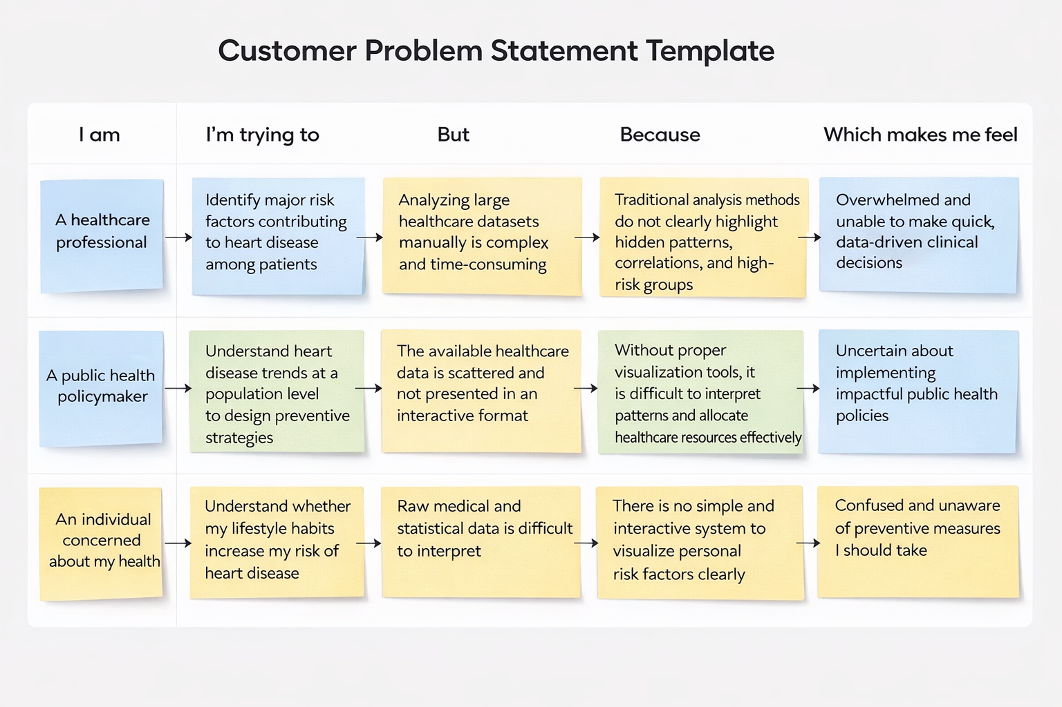

| **PS** | **I am** | **I’m trying to** | **But** | **Because** | **Which makes me feel** |
| --- | --- | --- | --- | --- | --- |
| **PS-1** | A healthcare professional | Find heart disease risk factors | Large health data is difficult to analyze | Data is not clearly visualized | Confused and slow in making decisions |
| **PS-2** | A public health policymaker | Understand heart disease trends | Data is scattered and not interactive | No proper visualization system | Unsure about planning health programs |
| **PS-3** | A health-conscious individual | Know my heart disease risk | Medical data is hard to understand | No simple tool to show risk clearly | Worried and unaware of prevention steps |
|  | | | | | |

**2.2. Empathy Map Canvas**

**Empathy Map Canvas:**

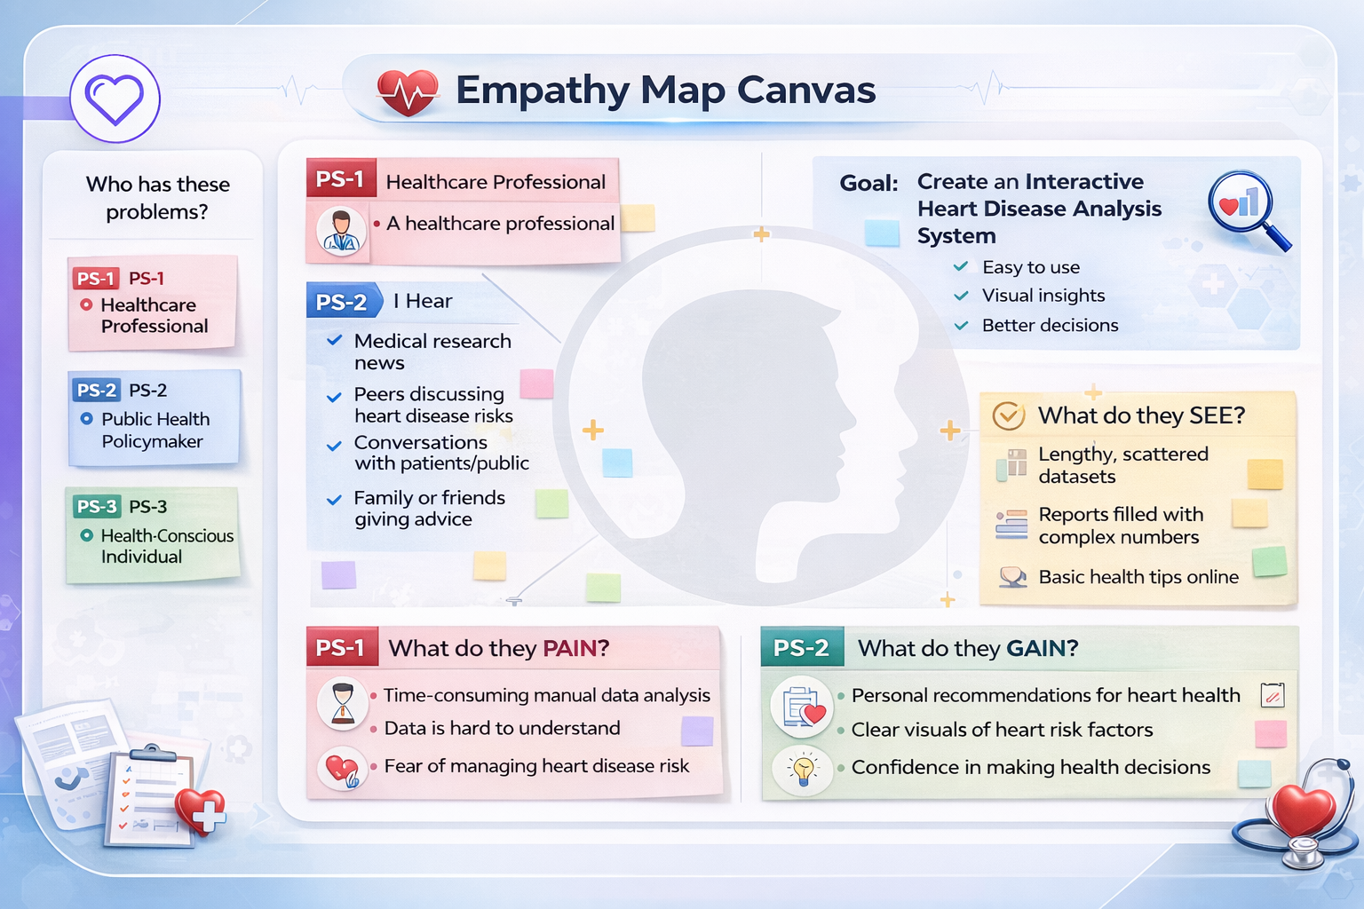

**2.3 Brainstorming**

**Brainstorm & Idea Prioritization:**

Brainstorming provides a collaborative and open environment where team members share ideas to solve the identified problem. In this project, brainstorming was conducted to explore different ways to analyze heart disease data and present meaningful insights through visualization. The main focus was to transform complex healthcare data into simple, interactive, and understandable dashboards.

All ideas were discussed freely, and practical solutions were selected based on feasibility, clarity, and impact.

**Step-1: Team Gathering, Collaboration and Select the Problem Statement**

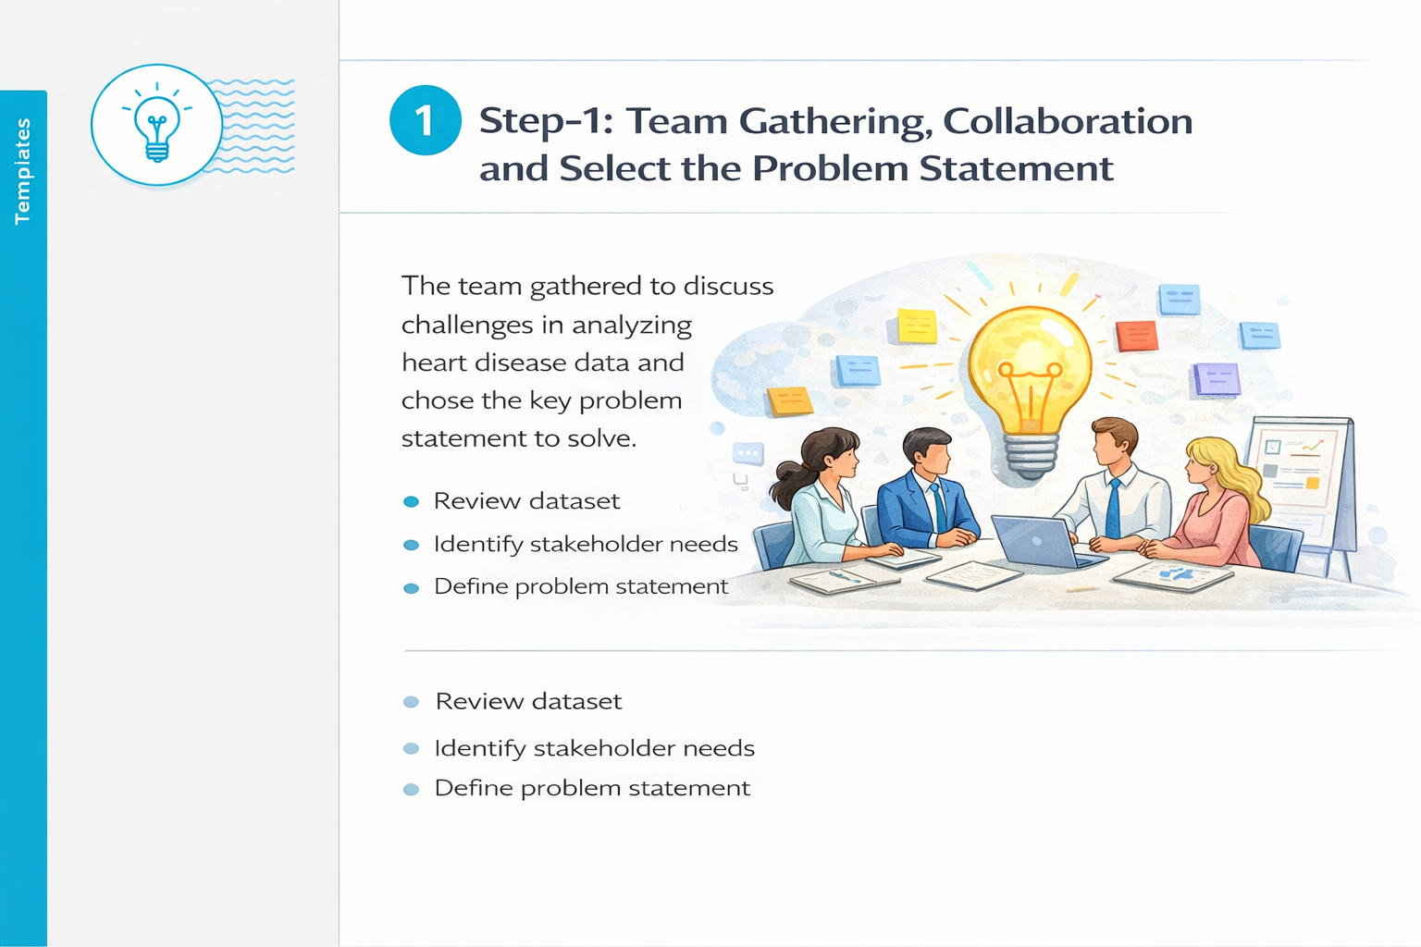

**Step-2: Brainstorm, Idea Listing and Grouping**

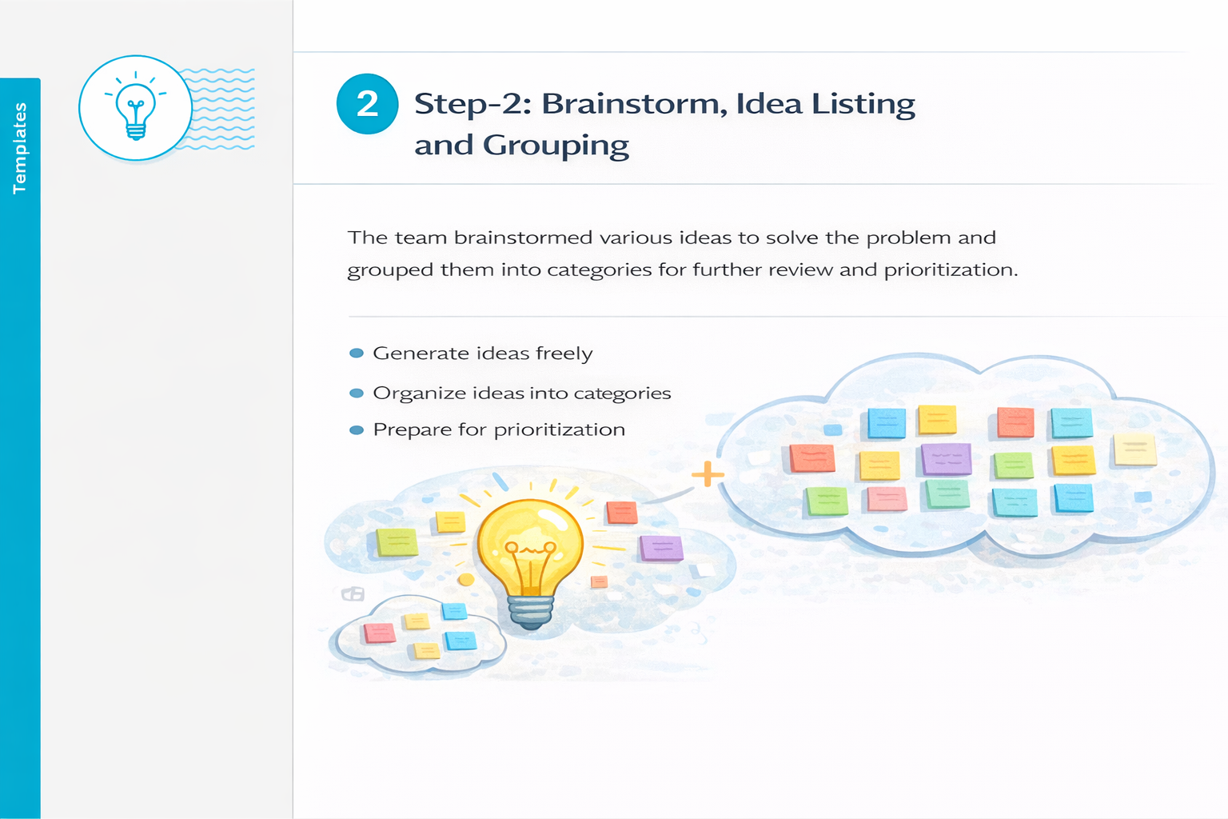

**Step-3: Idea Prioritization**

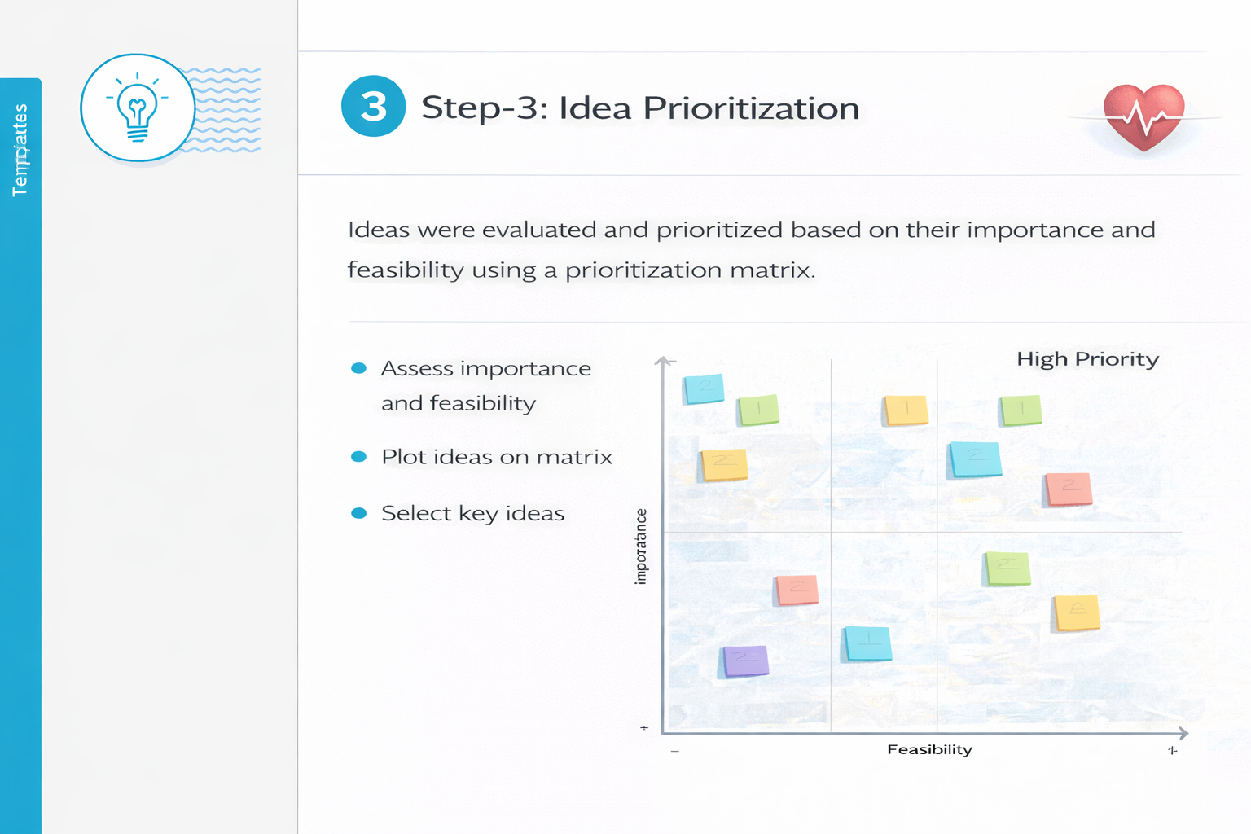

**3. Requirement Analysis**

**3.1. Solution Requirement**

**Functional Requirements:**

Following are the functional requirements of the proposed solution.

| **FR No.** | **Functional Requirements** | **Sub Requirements** |
| --- | --- | --- |
| **FR-1** | Data Import Module | Import heart disease dataset into Tableau |
| **FR-2** | Data Processing | Clean and organize dataset fields |
| **FR-3** | Visualization Creation | Create charts for age, BMI, smoking, diabetes, etc. |
| **FR-4** | Dashboard Design | Combine multiple visualizations into interactive dashboard |
| **FR-5** | Story Development | Create story to explain insights step-by-step |
| **FR-6** | Dashboard Publishing | Publish dashboard on Tableau Public |
| **FR-7** | Web Integration | Embed Tableau dashboard into Flask application |
| **FR-8** | UI Display | Display dashboard properly in web interface |

**Non-Functional Requirements**

Following are the non-functional requirements of the proposed solution.

| **NFR No.** | **Non-Functional Requirement** | **Description** |
| --- | --- | --- |
| **NFR-1** | Usability | The web application must have a simple and user-friendly interface. |
| **NFR-2** | Security | The application should not expose sensitive data publicly. |
| **NFR-3** | Reliability | The dashboard should load correctly without errors. |
| **NFR-4** | Performance | The dashboard should load within a few seconds. |
| **NFR-5** | Availability | The published dashboard should be accessible online. |
| **NFR-6** | Scalability | The system should support multiple users accessing the dashboard. |

**3.2. Data Flow Diagram**

**Data Flow Diagrams:**

A Data Flow Diagram (DFD) is a traditional visual representation of the information flows within a system. A neat and clear DFD can depict the right amount of the system requirement graphically. It shows how data enters and leaves the system, what changes the information, and where data stored. 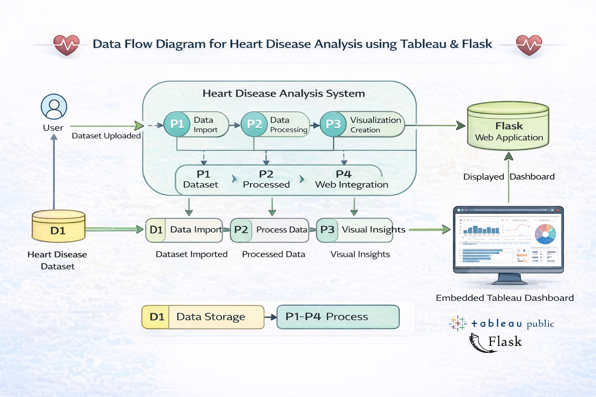

**User Stories**

Use the below template to list all the user stories for the product.

| **User Type** | **Functional Requirement (Epic)** | **User Story Number** | **User Story / Task** | **Acceptance Criteria** | **Priority** | **Release** |
| --- | --- | --- | --- | --- | --- | --- |
| Healthcare Professional | Data Visualization | USN-1 | As a user, I want to view heart disease data through interactive charts. | I can view multiple visualizations clearly in the dashboard. | High | Sprint-1 |
| Data Analyst | Data Processing | USN-2 | As a user, I want the dataset to be cleaned and structured before visualization. | Data is properly processed and organized in Tableau. | High | Sprint-1 |
| Public Health Policymaker | Dashboard Design | USN-3 | As a user, I want to explore heart disease trends using filters. | I can apply filters like age, gender, and smoking to analyze trends. | High | Sprint-2 |
| Healthcare Professional | Story Creation | USN-4 | As a user, I want to view insights in a story format for better understanding. | I can navigate through story scenes explaining key insights. | Medium | Sprint-2 |
| General User | Web Integration | USN-5 | As a user, I want to access the dashboard through a web application. | I can open and view the dashboard in the browser via Flask. | High | Sprint-3 |
| System Administrator | Deployment | USN-6 | As a user, I want the dashboard to be published and accessible online. | The dashboard is successfully published on Tableau Public. | Medium | Sprint-3 |

**3.3. Technology Stack**

**Technical Architecture:**

**Table-1: Components & Technologies**

| **S.No** | **Component** | **Description** | **Technology** |
| --- | --- | --- | --- |
| 1. | User Interface | Web-based interface where users can view the heart disease dashboard | HTML, CSS |
| 2. | Application Logic | Handles routing and rendering of web pages | Flask (Python Web Framework) |
| 3. | Data Source | Heart disease dataset used for analysis | CSV Dataset |
| 4. | Data Processing | Cleaning and organizing dataset for visualization | Tableau |
| 5. | Data Visualization | Creation of charts, dashboards, and stories | Tableau Public |
| 6. | Dashboard Publishing | Publishing dashboard for online access | Tableau Public |
| 7. | Dashboard Integration | Embedding Tableau dashboard into Flask web application | iFrame / Tableau Embed Code |
| 8. | Infrastructure (Server / Local) | Running the web application and hosting dashboard | Flask Local Server / Tableau Public |

**Table-2: Application Characteristics**

| **S.No** | **Characteristics** | **Description** | **Technology** |
| --- | --- | --- | --- |
| 1. | Open-Source Frameworks | Web framework and development tools used | Python, Flask, Tableau Public |
| 2. | Security Implementation | Ensures no sensitive data is exposed publicly | Controlled Data Publishing |
| 3. | Scalable Architecture | Web-based architecture supporting multiple users | Browser-based Access |
| 4. | Availability | Application accessible online after publishing | Tableau Public Hosting |
| 5. | Performance | Fast loading interactive dashboard with filters | Optimized Tableau Visualizations |

**4. PROJECT DESIGN**

**4.1. Problem Solution Fit**

**Problem – Solution Fit Template:**

Problem–Solution Fit refers to identifying a real problem faced by the target users and ensuring that the proposed solution effectively addresses that problem. In this project, healthcare professionals and policymakers face challenges in analyzing large heart disease datasets and extracting meaningful insights. The proposed solution — an interactive Heart Disease Analysis system using Tableau and Flask — directly solves this problem by converting complex data into clear, interactive visual dashboards.

This approach helps identify behavioral patterns, understand user needs, and implement a system that improves decision-making efficiency.

**Purpose:**

❑ Solve complex healthcare data analysis problems using interactive visualization techniques.

❑ Improve decision-making speed by presenting insights in a structured and user-friendly dashboard.

❑ Enhance communication of healthcare insights through clear visual representation and storytelling.

❑ Increase accessibility to heart disease data through web-based dashboard integration.

❑ Understand current data challenges and transform raw datasets into actionable insights for healthcare stakeholders.

**Template:**

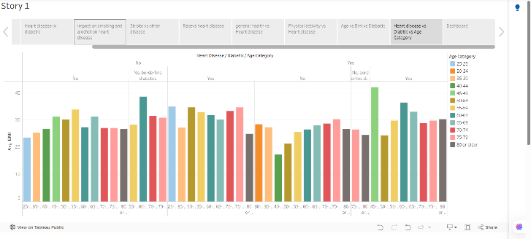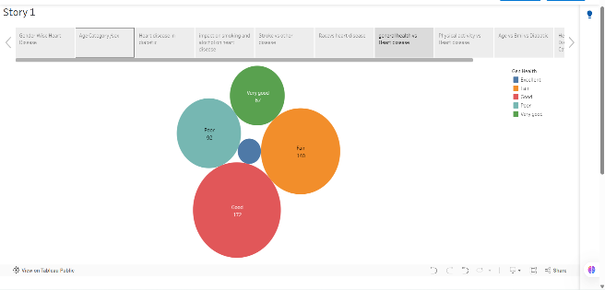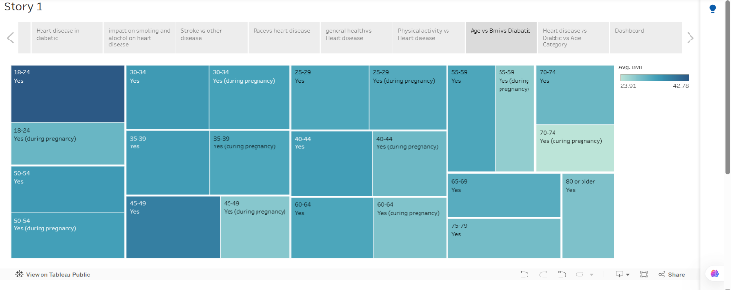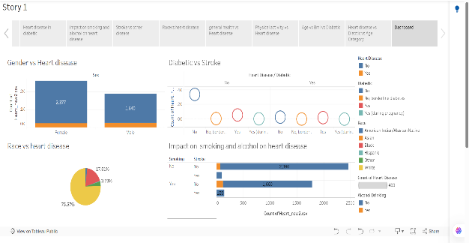

**4.2. Proposed Solution**

**Proposed Solution Template:**

Project team shall fill the following information in the proposed solution template.

| **S.No.** | **Parameter** | **Description** |
| --- | --- | --- |
| 1. | **Problem Statement (Problem to be solved)** | Healthcare professionals and policymakers face difficulty in analyzing large heart disease datasets and identifying key risk factors. Manual data analysis is time-consuming and does not clearly highlight patterns, trends, and correlations. There is a need for an interactive system that transforms raw healthcare data into meaningful visual insights for better decision-making. |
| 2. | **Idea / Solution Description** | The proposed solution is an interactive Heart Disease Analysis system developed using Tableau for data visualization and Flask for web integration. The system converts raw healthcare data into structured dashboards and stories that highlight important risk factors such as age, BMI, smoking, diabetes, and physical activity. The dashboard is published on Tableau Public and embedded into a web application for easy browser-based access. |
| 3. | **Novelty / Uniqueness** | Unlike traditional static healthcare reports, this system provides interactive visual dashboards with dynamic filters. Users can explore data in real-time, apply filters, and analyze trends easily. The integration of Tableau with Flask enables web-based accessibility, making the solution more flexible and user-friendly than static reports. |
| 4. | **Social Impact / Customer Satisfaction** | The solution helps healthcare professionals and policymakers make informed decisions based on data insights. It improves understanding of heart disease risk factors and supports preventive healthcare planning. Users benefit from clear visual representation of complex data, reducing confusion and improving productivity. |
| 5. | **Business Model (Revenue Model)** | The system can be extended for enterprise healthcare analytics services. Revenue can be generated through dashboard customization services, healthcare analytics consulting, subscription-based advanced analytics features, or integration with hospital management systems. |
| 6. | **Scalability of the Solution** | The dashboard is cloud-accessible through Tableau Public and can be deployed on scalable web infrastructure. The system can support multiple users accessing the dashboard simultaneously. Future enhancements such as real-time database integration, predictive analytics, and cloud hosting can further scale the solution. |

**4.3 Solution Architecture**

**Solution Architecture:**

The solution architecture of the Heart Disease Analysis system consists of a Tableau-based data visualization platform integrated with a Flask web application. The heart disease dataset is first imported into Tableau, where it is cleaned and structured for analysis. Multiple interactive visualizations are created to highlight important risk factors such as age, BMI, smoking, diabetes, and physical activity. These visualizations are combined into an interactive dashboard and story format to provide clear and meaningful insights.

The completed dashboard is published on Tableau Public for online accessibility and embedded into a Flask web application using an iframe or Tableau embed code. The Flask application acts as the interface layer, allowing users to access the dashboard through a web browser. This architecture ensures a simple, scalable, and user-friendly system that transforms raw healthcare data into interactive and actionable insights.

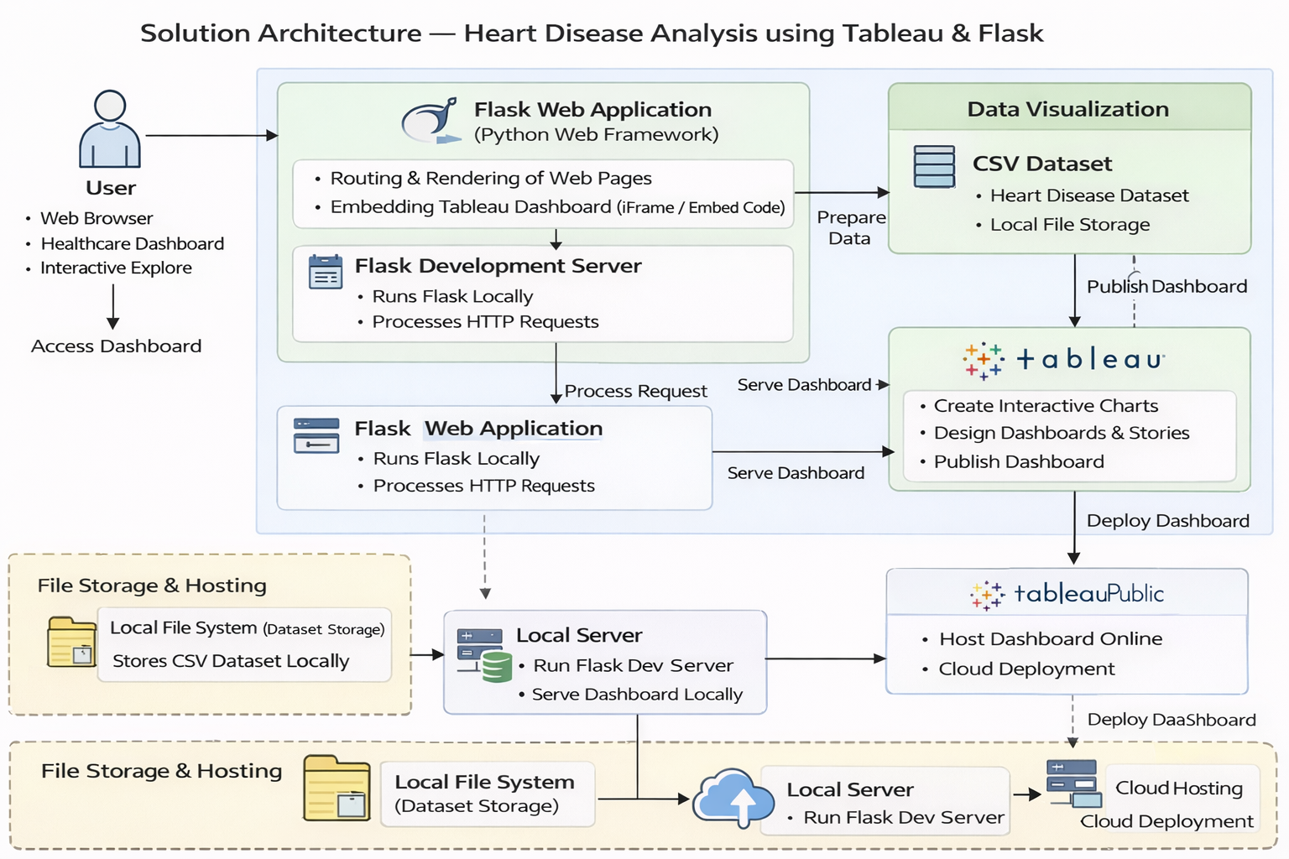

**5. PROJECT PLANNING & SCHEDULING**

**5.1. Project Planning**

Use the below template to create product backlog and sprint schedule

**Product Backlog, Sprint Schedule, and Estimation:**

| Sprint | Functional Requirement (Epic) | User Story Number | User Story / Task | Story Points | Priority | Team Members |
| --- | --- | --- | --- | --- | --- | --- |
| Sprint-1 | Database Setup | USN-1 | As a developer, I want to store the heart disease dataset in MySQL so that it can be queried efficiently. | 2 | High | All Team Members |
| Sprint-2 | SQL Data Processing | USN-2 | As a developer, I want to perform SQL queries to clean and filter the dataset for analysis. | 2 | High | All Team Members |
| Sprint-3 | Tableau Integration | USN-3 | As a user, I want Tableau to connect with MySQL to create interactive visualizations. | 3 | High | All Team Members |
| Sprint-4 | Visualization Development | USN-4 | As a user, I want to analyze heart disease risk factors using charts and graphs. | 3 | High | All Team Members |
| Sprint-5 | Dashboard Creation | USN-5 | As a user, I want to view all visual insights in a single interactive dashboard. | 2 | High | All Team Members |
| Sprint-6 | Flask Web Integration | USN-6 | As a user, I want the Tableau dashboard to be embedded in a Flask web application. | 2 | Medium | All Team Members |
| Sprint-7 | Deployment | USN-7 | As a user, I want the application to be deployed online for public access. | 2 | Medium | All Team Members |

**Project Tracker, Velocity & Burndown Chart: (4 Marks)**

| **Sprint** | **Total Story Points** | **Duration** | **Sprint Start Date** | **Sprint End Date (Planned)** | **Story Points Completed (as on Planned End Date)** | **Sprint Release Date (Actual)** |
| --- | --- | --- | --- | --- | --- | --- |
| Sprint 1 | 20 | 4 Days | 28 January 2026 | 31 January 2026 | 20 | 31 January 2026 |
| Sprint 1 | 20 | 4 Days | 28 January 2026 | 31 January 2026 | 20 | 31 January 2026 |
| Sprint 3 | 20 | 8 Days | 02 February 2026 | 09 February 2026 | 20 | 09 February 2026 |
| Sprint 4 | 20 | 8 Days | 02 February 2026 | 09 February 2026 | 20 | 09 February 2026 |
| Sprint 5 | 20 | 7 Days | 12 February 2026 | 18 February 2026 | 20 | 18 February 2026 |
| Sprint 6 | 20 | 7 Days | 12 February 2026 | 18 February 2026 | 20 | 18 February 2026 |

**6. FUNCTIONAL AND PERFORMANCE TESTING**

**6.1 Performance Testing**

**Test Scenarios & Results**

| **Test Case ID** | **Scenario (What to test)** | **Test Steps (How to test)** | **Expected Result** | **Actual Result** | **Pass/Fail** |
| --- | --- | --- | --- | --- | --- |
| FT-01 | Database Connection | Connect MySQL database to Tableau | Successful database connection established | Connected Successfully | Pass |
| FT-02 | SQL Query Execution | Run SELECT queries for filtering heart disease data | Correct filtered dataset returned | As Expected | Pass |
| FT-03 | Visualization Rendering | Load charts in Tableau dashboard | Charts display correct data without errors | As Expected | Pass |
| FT-04 | Dashboard Filter Functionality | Apply filters (Age, Gender, BMI, Smoking) | Dashboard updates dynamically based on filter | Working Properly | Pass |
| FT-05 | Flask Web Integration | Open Flask app and load embedded Tableau dashboard | Dashboard loads inside web page | As Expected | Pass |
| PT-01 | Dashboard Load Time | Open dashboard and measure load time | Dashboard loads within 3–5 seconds | Within Limit | Pass |
| PT-02 | Multiple Filter Usage | Apply multiple filters simultaneously | System handles filtering without lag | Stable | Pass |
| PT-03 | Deployment Test | Access deployed application through browser | Application loads and works correctly online | Working | Pass |

**7. RESULTS**

**7.1. Output Screenshots**

**Step 1: Running the Flask Application**

To execute the application, open the terminal in the project directory where the app.py file is located and run the following command:

python app.py

This command starts the Flask development server.

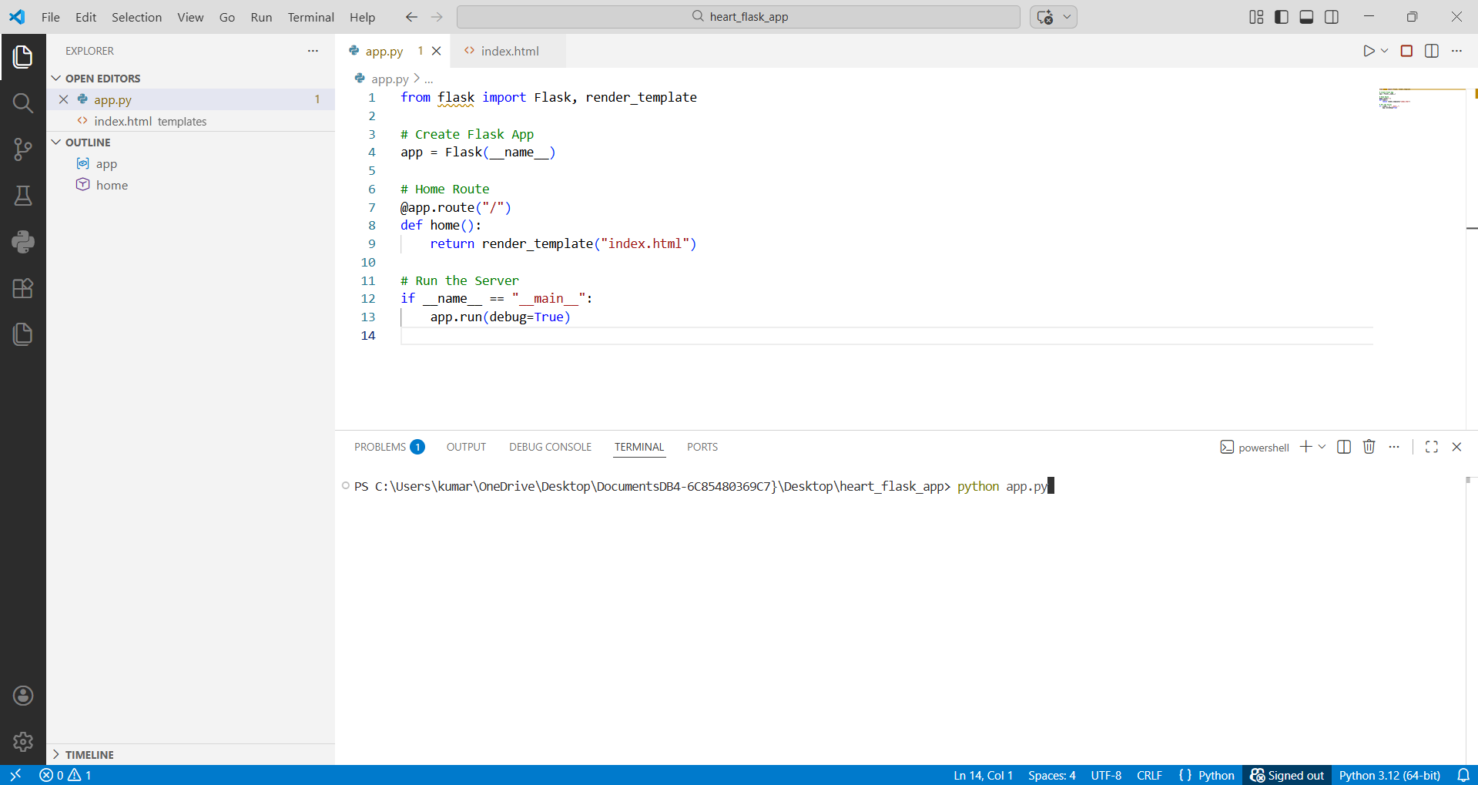

**Step 2: Accessing the Application**

After running the command, the terminal generates a local host URL such as:

http://127.0.0.1:5000

The user can access the application by opening this URL in a web browser. Upon accessing the link, the web page loads successfully.

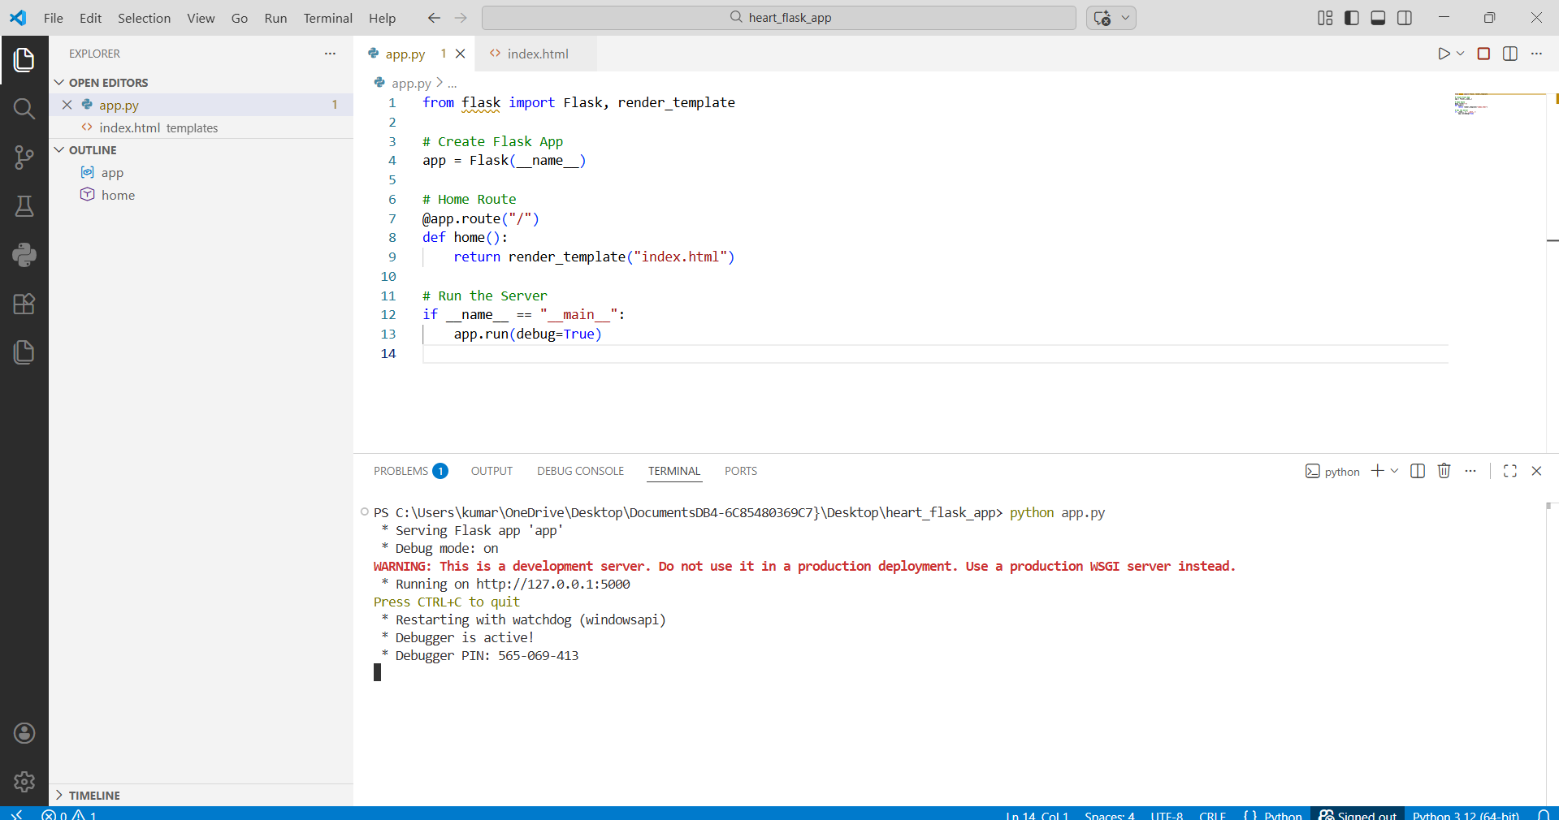

**Step 3: Application Homepage Display**

The Flask web page opens and displays the homepage of the Heart Disease Analysis application. The homepage contains:

* Project Title
* Brief description of the system
* Embedded Tableau Dashboard

The interface is developed using Flask templates, and the dashboard is integrated using Tableau’s embed functionality.

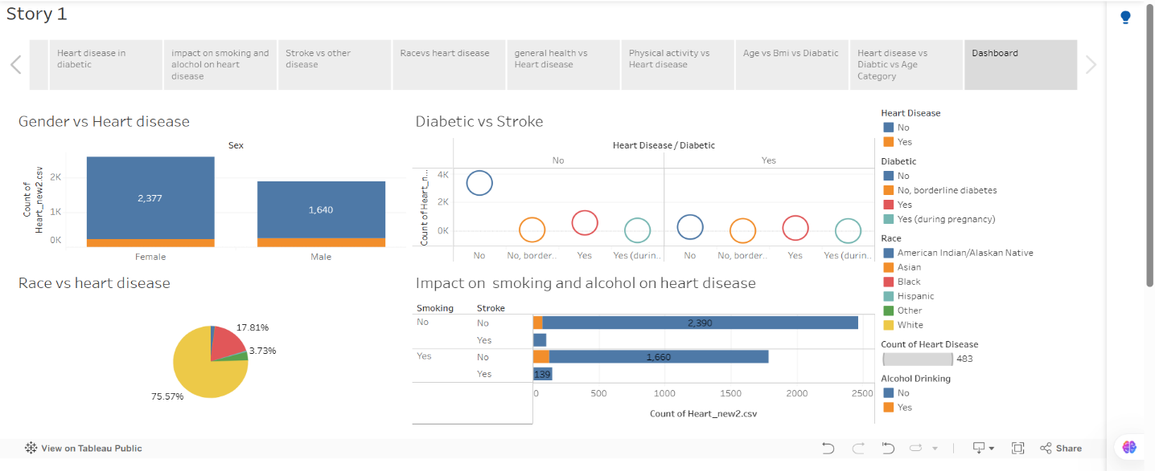

**Step 4: Dashboard Interaction**

Once the dashboard loads, users can interact with various filters such as:

* Age
* Gender
* BMI
* Smoking Status
* Diabetes Status
* Physical Activity

When filters are applied, the dashboard dynamically updates the visualizations in real time.

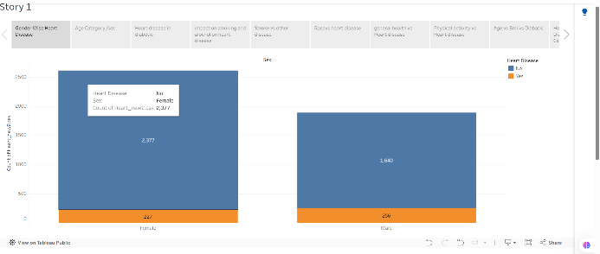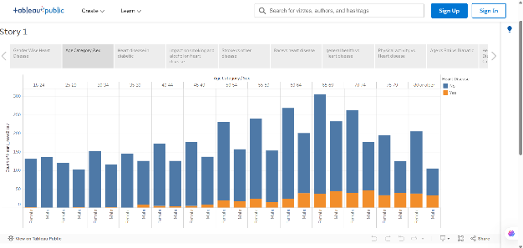

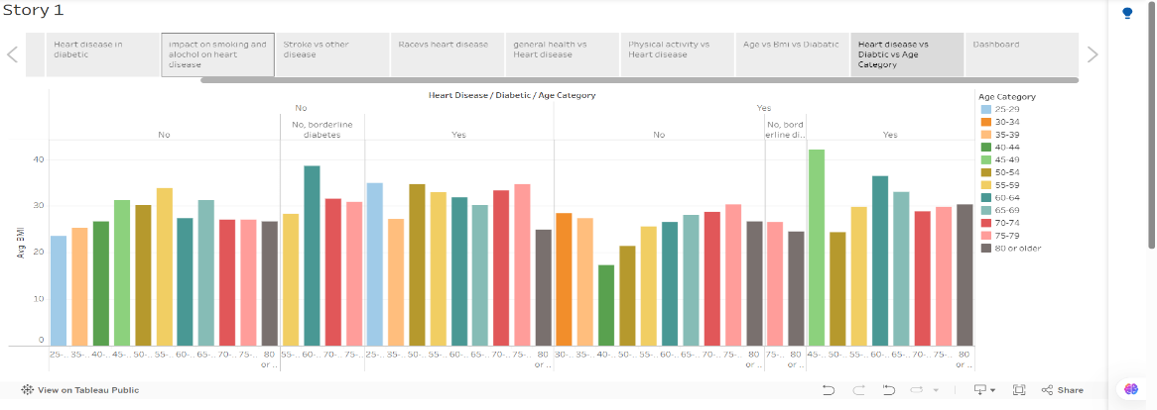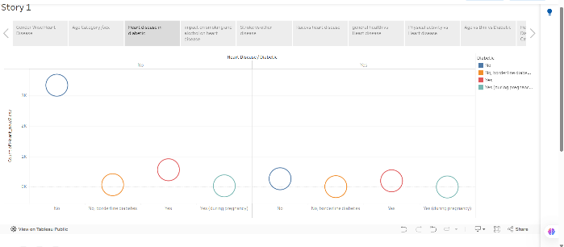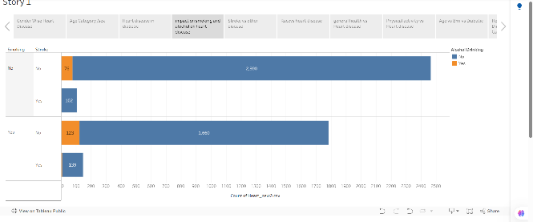**Step 5: Visualization Output**

The dashboard displays multiple visualizations including:

* Gender-wise Heart Disease Analysis
* Age vs Heart Disease Trends
* Impact of Smoking and Alcohol
* Diabetes and Stroke Correlation
* Physical Activity vs Heart Disease
* Combined Age and BMI Analysis

These visualizations provide meaningful insights into heart disease risk factor

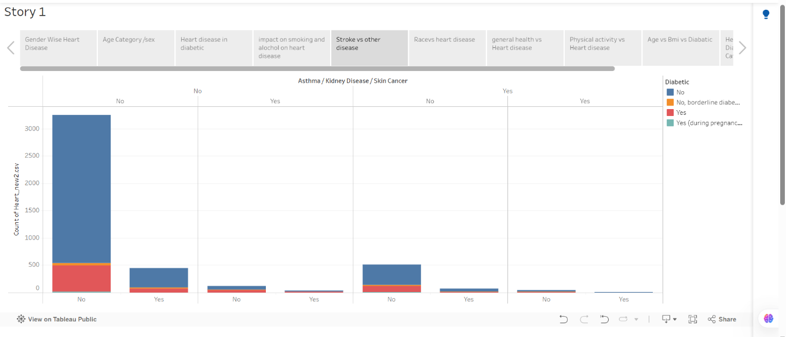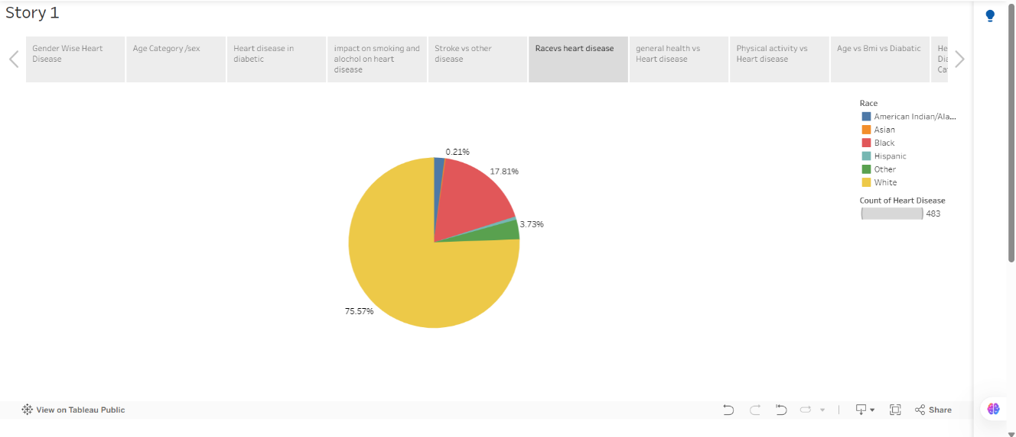

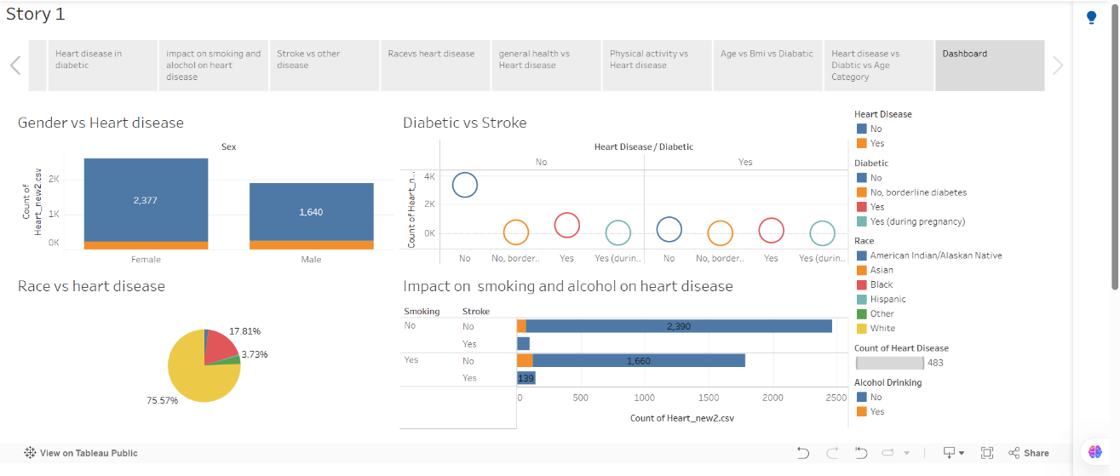

**Step 6: Deployment and Accessibility**

After deployment, the application becomes accessible through a public URL. The system functions correctly online, and all interactive components operate without errors.

**8. ADVANTAGES AND DISADVANTAGES**

**Advantages**

• Helps identify key risk factors contributing to heart disease  
• Enables data-driven decision making for healthcare professionals  
• Provides interactive and dynamic visualizations using Tableau  
• Reduces manual data analysis effort  
• Real-time dashboard filtering for better insights  
• Integrates database, visualization, and web deployment in a single system  
• User-friendly interface through Flask web integration

**Disadvantages**

• Requires internet connection for accessing Tableau Public dashboards  
• Performance depends on database query optimization  
• Limited to available dataset (no real-time hospital data integration)  
• Requires basic technical knowledge to maintain or update system  
• Data accuracy depends on dataset quality

**9. CONCLUSION**

The **Heart Disease Analysis using Tableau and Flask** project successfully demonstrates how data visualization and business intelligence tools can be used to analyze healthcare data effectively. The system transforms raw heart disease data into meaningful visual insights through interactive dashboards.

By integrating MySQL for data storage, SQL for processing, Tableau for visualization, and Flask for web deployment, the project provides a complete end-to-end analytics solution. The dashboard enables healthcare professionals, policymakers, and individuals to understand risk factors such as age, BMI, smoking, diabetes, and physical activity, thereby supporting preventive healthcare decisions.

**10. FUTURE SCOPE**

The project can be enhanced further by integrating real-time hospital data for live monitoring of heart disease trends. Future improvements may include adding predictive analytics using Machine Learning models to estimate heart disease risk levels.

The system can also be extended with:

• AI-based risk prediction models  
• Real-time health monitoring integration  
• Role-based user login system  
• Advanced analytics with trend forecasting  
• Mobile application deployment

These enhancements can transform the system into a comprehensive healthcare decision-support platform.

**11. APPENDIX**

**11.1 Source Code**

The source code for the **Heart Disease Analysis using Tableau and Flask** project includes:

* MySQL database setup and SQL queries for data storage and processing
* Tableau dashboard creation and visualization logic
* Flask web application code for embedding the Tableau dashboard
* HTML templates used for rendering the web interface

The application is developed using **Python (Flask framework)** and follows a structured and modular approach to ensure readability, maintainability, and scalability.

**11.2. Github & Project Demo Link**

**Github Repository Link:** - <https://github.com/DurgalakshmiPeketi/Heart-Disease-Analysis>

**Demo Link:** [**https://drive.google.com/file/d/1kJAkLYCZZoUqpopoY0Mk4rSr9GPWN8Cf/view?usp=sharing**](https://drive.google.com/file/d/1kJAkLYCZZoUqpopoY0Mk4rSr9GPWN8Cf/view?usp=sharing)